Effect of nickel precursor and catalyst activation temperature on methanation performance
B.Buyan-Ulzii, O.Daariimaa, Ch.Munkhdelger, G.Oyunbileg and B.Enkhsaruul*
Laboratory of Clean Energy Technology Development, School of Arts & Sciences, National University of Mongolia, Ulaanbaatar 14201, Mongolia
E-mail: enkhsaruul_b@num.edu.mn
Abstract
This work studied an effect of anionic precursor on the preparation of active and fine nickel metal catalysts for syngas methanation. Nickel catalysts were prepared using by a method of impregnation-co-precipitation. Nickel hydrate salts of Ni(NO₃)₂·6H₂O, NiSO₄·6H₂O and NiCl₂·6H₂O were used as a metal catalyst precursor, and the obtained catalysts were named as Ni/Al (N), Ni/Al (S) and Ni/Al (Cl), respectively. Methanation synthesis of carbon monoxide was carried out in a fixed bed stainless reactor. Prior to experiment, the catalyst powder was pressed into tablets, then crushed and sieved to use 0.5-0.9 mm particles. Reactions were performed at the temperature of 350°C in the pressure of 3 atm of H₂ : CO syngas (the molar ratio of 3:1) with the GHSV of 3000 h⁻¹. In the present methanation conditions, the Ni/Al (N), Ni/Al (S) and Ni/Al (Cl) catalysts gave the CH₄ selectivity of 93%, 18% and 91% (vol.), respectively. The XRD and ICP-OES analysis clarified that although the Ni/Al (S) catalyst contained a similar nickel amount of 17.4 wt% to other two catalysts, its metal distribution was poor. Also the low activity of the Ni/Al (S) catalyst was caused by the contamination of remained sulfur from sulfate precursor. This work also examined an influence of catalyst activation temperature pre-synthesis. The Ni/Al (N) catalyst was reduced by pure hydrogen gas at different temperatures of 350°С, 400°С or 450°С. The catalyst activated at 400°С produced the highest CH₄ amount of 0.087 mmol/g-cat for the duration of 1h methanation. An initial temperature of methane formation was the lowest for the Ni/Al (N) catalyst which was activated at 400°С among three catalysts.

Keywords
CO hydrogenation, primary anion, catalyst reduction

Introduction
World energy committee reported a strategy of global energy application and structure till 2035. It was known in the report that energy coal and petroleum consumption would be decreased by 0.7 billion tons and 0.5 billion tons, respectively; however natural gas consumption would increase by 1560 billion m³ in target year. Many developed countries accepted the natural gas as their primary energy source. Consequently, a need for natural gas production and import increased significantly in many countries. In spite of huge deposits of energy coal, Mongolia has no resource of natural gas excluding coal bed methane. Generally, lignite calorie is estimated approximately by 16-24 MJ/kg, however natural gas generates 2 times higher calorie compared to lignite [1, 2]. Besides its low caloric value, lignite has disadvantage to utilize it as a fuel in populated city, and becomes a source of toxic emission and environmental pollution [3]. Therefore, our country has the necessity of producing substitute natural gas (SNG) in order to meet increasing energy demand and environmental regulations. A research on methanation is important not only because of the increase need of a high caloric fuel, but also because of clean fuel utilization [5-13]. We clarified an efficient method of impregnation-co-precipitation to prepare nickel catalyst of methanation in our previous study [4]. In the present study, we aimed to examine an effect of primary anion precursors, which were used in impregnation-co-precipitation to prepare a nickel catalyst, on methanation activity of carbon monoxide. Also this research work had a purpose to clarify an influence of activation temperature of nickel catalyst prior to catalyst evaluation test on CO conversion and methane selectivity.

Experimental methods
Catalyst preparation
Impregnation-co-precipitation method was applied to load nickel precursor onto γ-Al₂O₃. Reagents used as a precursor solution of nickel metal were nickel (II) nitrate hexahydrate ((Ni(NO₃)₂∙6H₂O), nickel (II) sulfate hexahydrate (NiSO₄∙6H₂O) and nickel (II) chloride hexahydrate (NiCl₂∙6H₂O). The corresponding catalysts were described as Ni/Al (N), Ni/Al (S) and Ni/Al (Cl). Nominal nickel contents were 20 wt% for every catalyst. The precipitation by sodium carbonate was done at 50°С with a continuous stirring. The precipitate was filtrated using by a Buchner funnel, and washed three times by distilled water. The obtained samples were dried at 110°С for 12 h, and calcined at 500°С for 1 h, and reduced at 350°С, 400°С or 450°С in 100% H₂ gas flow with a rate of 13 ml/min. All catalyst powder were molded, then crushed and sieved to prepare particle size between 0.5 and 0.9 mm in diameter.
Catalytic activity test
Catalytic activity was measured by a fixed bed stainless tubular reactor (8 mm in inner diameter). The catalyst was placed in the mid of tubular reactor, and about 1 g of catalyst was used in every experiment. After the activation treatment by 100% H₂ with a flow rate of 13 ml/min, the reducing gas was switched by a mixture gas of H₂ and CO (molar ratio of 3:1) with a flow rate of 50 ml/min, and synthesis pressure was collected until 3 atm by the regulation valve of BPR. Catalyst evaluation tests were carried out at 350°С for 1h. The value of GHSV was 3000 h⁻¹. Composition of outlet gases were analyzed using a gas chromatograph equipped with a TCD (YL6100 GC) every 5 min of reaction. Fixed bed reactor system of methanation synthesis was illustrated in Scheme 1.
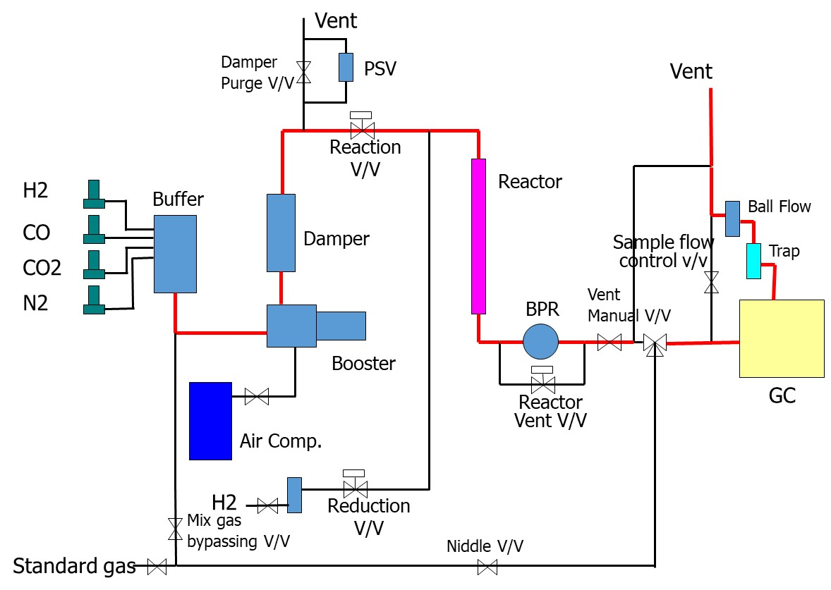
Scheme 1. Fixed bed reactor system of methanation synthesis.
СО conversion, methane selectivity and yield were calculated by the next equations.
CO conversion: $X_{CO}\left(\%\right)= \frac{V_{CO,inlet}-V_{CO,outlet}}{V_{CO, inlet}}×100$ (1)
Меthane selectivity: $S_{{CH}_{4}}\left(\%\right)= \frac{V_{{CH}_{4}, outlet}}{V_{{CH}_{4}, outlet}+V_{{CO}_{2}, outlet}+V_{H_{2}, outlet}}×100$ (2)
Меthane yield: $Y_{{CH}_{4}}(\%)=\frac{X_{CO}×S_{{CH}_{4}}}{100}$ (3)

Catalyst characterization
X-ray diffraction patterns of fresh and used catalysts were recorded using a diffractometer (XRD mini Flex 600) employing with Co Kα radiation (40 kV, 30 mA). The diffraction angle was selected from 5° to 70° with a scan rate of 5°/min and step size of 0.01°.
BET surface area was measured using by Flowsorb ΙΙΙ 2305/2310. Nitrogen adsorption was done in pressure of 88.9 MPa at the temperature of 21.4°C in N₂ flow with a rate of 53 ml/min. Approximately 10 mg of catalyst sample was loaded in a glass tube and outgassed at 150°C for 1h in a N₂ gas flow. Nickel contents in fresh catalysts were determined using by a method of ICP-OES (ICP-OES6500).

Results and discussion
Effect of nickel catalyst precursor on catalytic activity of methanation.
After the impregnation-co-precipitation, actual contents of nickel catalysts were measured using by a method of ICP-OES. It was identified that when nickel content of the catalysts was nominally expected as 20 wt%, the obtained contents were between in approximately 17–19 wt% depending on primary anion type of metal precursors. Table 1 shows the nominal and experimental contents of nickel metal precipitated by the impregnation-co-precipitation method using different anion precursors.
Table 1. Contents of nickel metal precipitated by an impregnation-co-precipitation method using different anion precursors
Catalyst code | Ni content, wt%
 | Nominal | Experimental¹⁾
Ni/Al (N) | 20.0 | 16.6
Ni/Al (S) | 20.0 | 17.4
Ni/Al (Cl) | 20.0 | 18.5
- Determined by ICP-OES analysis
Fresh catalysts of Ni/Al (N), Ni/Al (S) and Ni/Al (Cl) were analyzed by X-ray diffractometer to check crystalline phases of nickel particles depending on their metal precursor after drying treatment at 110°C for 12 h and calcination at 500°C for 1 h. Figure 1 describes the X-ray diffractograms of the obtained catalysts before methanation process. Main detected peaks of X-ray diffraction were for ɤAl₂O₃ at around 79.59° and 53.55°, and for NiO at around 50.63°, 43.45° and 74.43° in all fresh catalysts. It was known that when nickel methanation catalyst was prepared by the impregnation-co-precipitation method, there were no nickel aluminate species, which were inactive catalytically and non-reducible, in the catalysts [3]. This data proved that the strong chemical interaction between metal catalyst and ɤAl₂O₃ support material did not occur during the present catalyst preparation condition [5, 14, 16]. Intensity of the strongest peak at 50.63° of NiO species in Ni/Al (N) was higher compared to other catalysts, even though their nickel contents were similar. It might suggest the low crystallinity of nickel oxides in Ni/Al (S) and Ni/Al (Cl) catalysts.
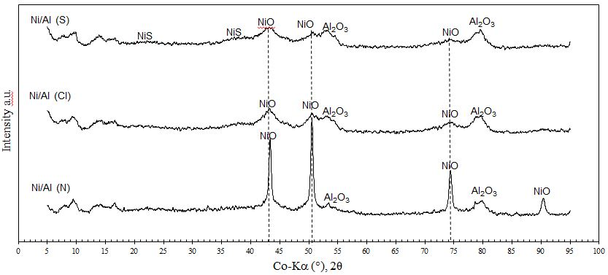
Figure 1. X-ray diffractograms of the obtained catalysts of Ni/Al (N), Ni/Al (S) and Ni/Al (Cl) ( -NiO, -Al₂O₃)
Table 2 shows surface areas of the obtained fresh catalysts. It was observed that there were no significant differences between the values of catalyst surface areas. These data suggested, when catalyst loading method and catalyst support were same, nickel precursor type did not affect textural properties of the catalysts.
Table 2. BET surface areas of the obtained catalysts of Ni/Al (N), Ni/Al (S) and Ni/Al (Cl)
Catalyst code | Surface area, m²/g
Ni/Al (N) | 130.6
Ni/Al (S) | 119.7
Ni/Al (Cl) | 127.8
Activities of the obtained catalysts prepared using the different salts of nickel precursor were tested at the reaction temperature of 350°С under the syngas pressure of 3 atm. Catalyst activity was evaluated using by the parameters of CO conversion, CH₄ selectivity and CH₄ yield.
CO + 3H₂ → CH₄ + H₂O ΔH=-206 kJ/mol (1)
Carbon monoxide methanation is an exothermic reaction. The conversion of carbon monoxide is referred to as CO methanation (Eq. 1). Four mole of feed gases produces two mole of product, consequently reactant volume decreases 2 times and thermodynamically, low temperature and high pressure favor the methane production [5, 18].
CO + H₂O → CO₂ + H₂ (2)
Moreover, due to the produced water, a water-gas shift reaction (Eq. 2) accompanies the CO methanation reaction using nickel catalysts in practical operation to produce a by-product of CO₂ [19-22].

Figure 2. CO, CH₄ and CO₂ contents during methanation synthesis with the Ni/Al(N) catalyst
Feed gas contains 25% of CO and 75% of H₂. As shown in Figure 2, the Ni/Al (N) catalyst converts almost fully the carbon monoxide into methane. In the end of reaction, the content of CO was only 0.8% in product gas. It was known also that some part of CO gas was expended to produce CO₂ because of a water-gas shift reaction. However, the concentration of CO₂ was approximately 7.1% in the product gas. Catalyst activity of the Ni/Al (N) catalyst was compared with those of Ni/Al (S) and Ni/Al (Cl) in Figures 3 (a) and 3 (b).

Figure 3 (a) and (b). CO conversion and methane selectivity obtained during the synthesis with the catalysts prepared from different metal precursors
CO conversion with time over catalysts prepared from different precursors was presented in Figure 3 (a). From this figure, it could be seen that within the tested time, CO conversion increased with time significantly for Ni/Al (N) and Ni/Al (Cl) catalysts, however CO conversion was very small and slowly increased for the Ni/Al (S). The methane selectivity had a similar tendency with the CO conversion for every catalyst with reaction time. Thus, an effect of catalyst precursor on the methanation performance could be summarized in the order of: Ni/Al (N)≈Ni/Al (Cl)>Ni/Al (S). These results indicated that the nitrate and chloride salts were good precursors than sulfate based on activity consideration. However, chloride precursor is unfavorable environmentally because of a persistent organics emission source, therefore it was assumed that nickel nitrate was the best candidate for methanation catalyst precursor [22]. According to the characterization results of fresh catalysts (Table 1, 2 and Figure 1), no significant differences were observed for the properties of three fresh catalysts. Moreover, the catalysts contained similar amounts of nickel metal species, and their surface areas were almost same. Though the catalysts were prepared using the same method of impregnation-co-precipitation, the catalytic performance of Ni/Al (S) only was very low. In order to examine a possible residual sulfur effect on catalytic activity, total sulfur of fresh catalysts were determined. Table 2 exhibited that the Ni/Al (S) contained 0.45 wt% of sulfur, whereas the sulfur contents of other catalysts were lower than the detection limit of a weight difference method (<0.10 wt%). Based on these results, we could conclude that a residual sulfur in the precipitate from sulfate precursor could not be removed fully by the same washing procedure as that for Ni/Al (N) and Ni/Al (Cl) catalysts. Therefore, active nickel surface of the Ni/Al (S) was covered by sulfur to generate NiS film on catalyst perhaps after catalyst calcination, because no bulky sulfided species were detected in the Ni/Al (S) as showing in Figure 1. Again it was considered that the nitrate precursor was the most convenient choice for the preparation of methanation catalyst.

Table 2. Sulfur contents in the obtained catalysts of Ni/Al (N), Ni/Al (S) and Ni/Al (Cl)
Catalyst code | Total sulfur, wt%
Ni/Al (N) | <0.10
Ni/Al (S) | 0.45
Ni/Al (Cl) | <0.10

X-ray diffraction analysis of the used Ni/Al (N) and Ni/Al (S) catalysts after methanation for 1h described an existence of unreduced NiO species in the catalyst which was prepared by a sulfate precursor. As shown in Figure 4, it was also identified that crystallinity of metallic Ni° was sharp in the Ni/Al (N), and the main peaks of X-ray diffraction were for Ni° at around 52.1°, 60.9° and 91.7°.
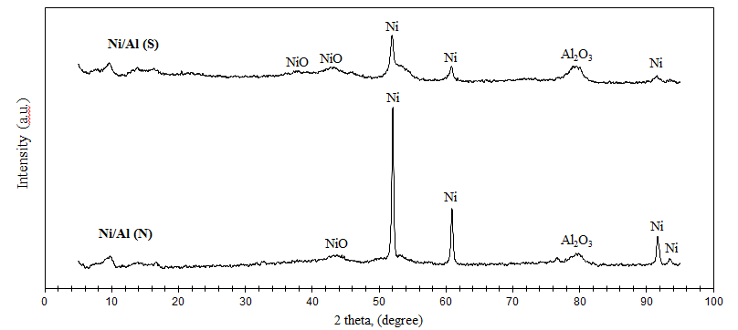
Figure 4. X-ray diffractograms of the Ni/Al(N) and Ni/Al(S) catalysts after methanation for 1h
It was concluded that the sharp peaks of Ni° species represented more amount of reduced nickel in the Ni/Al (N). Therefore, nickel catalyst precursor of nitrate was able to produce high density of reducible NiO species, which eventually generated highly active Ni⁰ particles after hydrogen activation, on the surface of ɤAl₂O₃ support.

Effect of catalyst activation temperature on methanation activity.
Catalytic activities of the catalyst prepared by the nitrate precursor for CO methanation as a function of activation temperature are shown in Figure 5 (a) and (b). Methanation condition was not changed and kept at the reaction temperature of 350°C, in the pressure of 3 atmosphere for 1 h. The GHSV of feed H₂ and CO gases was 3000 h⁻¹. Prior methanation, the Ni/Al (N) catalyst was reduced by pure H₂ gas with a flow rate of 13 ml/min for 60 min to prepare active Ni° phase in a catalyst for CO methanation.

Figure 5 (a) and (b). CO conversion and methane selectivity during synthesis with the Ni/Al(N) catalysts activated at the temperature of 350°С, 400°С or 450°С prior methanation synthesis
As seen from Figure 5 (a) and (b), CO conversion occurred at the initial reaction time of 5 min on the Ni/Al (N) catalyst, which was activated at 400°C by pure hydrogen. In the temperature range of 116-305°C (corresponding to reaction time of 20-40 min), CO conversion and CH₄ yield gave an evident upward trends with the increase of reaction temperature for the Ni/Al (N) activated at 400°C, however at the same temperature trend CO conversion on the catalyst, which was activated at 350°C or 450°C, started around after 30-40 min of synthesis. Therefore, as shown in Figure 5 (a) and (b), the Ni/Al (N) catalyst, which was activated at 400°C, exhibited the highest CO conversion and CH₄ yield. In present study, methanation temperature reached to the designated 350°C after 45 min of reaction. Table 3 compared the specific performance of three Ni/Al (N) catalysts, which were activated at 350°C, 400°C or 450°C, at the reaction time of 45 min in CO methanation.
Table 3. Comparison of CO methanation performance for three Ni/Al (N) catalysts activated at different temperatures
Activation temperature, °C | CO conversion, % | CH₄ selectivity, % | CO₂ selectivity, %
350 | 63.00 | 86.46 | 0.14
400 | 73.91 | 92.07 | 0.07
450 | 55.51 | 85.75 | 0.10

As showing in Table 3, the Ni/Al (N) catalyst activated at 400°C gave the highest CO conversion, CH₄ selectivity and the lowest CO₂ selectivity among three catalysts. This result clarified an appropriate activation temperature of the Ni/Al (N). Figure 6 shows the initial temperatures of CH₄ formation and the CH₄ total productivities of three Ni/Al (N) catalysts, which were activated at 350°C, 400°C or 450°C. The CH₄ total productivity was calculated by a sum of produced CH₄ amount per unit of catalyst weight for 1 h methanation. The performance of three catalysts were tested under the same conditions of methanation process. It was known that an initial temperature to form methane by the Ni/Al (N) catalyst activated at 400°C was the lowest at 215°C, and it produced the highest amount of methane (0.087 mmol/g-cat) for 1 h methanation among three catalysts.

Figure 6. CH₄ formation T () and CH₄ productivity () during the synthesis with the Ni/Al(N) catalysts activated at the temperatures of 350°С, 400°С and 450°С prior methanation synthesis
However, the catalyst, which was activated at 450°C, produced methane from the temperature of 233°C. It might be related to catalyst agglomeration during hydrogen reduction at very high temperature. Moreover, an initial temperature to form methane by the catalyst activated at 350°C was not so high (225°C), but it produced the smaller amount of methane in comparison with the catalyst activated at 400°C.

Conclusion

Effects of precursor type of nickel metal and catalyst activation temperature on methanation performance were tested at the temperature of 350°C, in the pressure of 3 atmosphere of H₂ : CO syngas with a GSHV of 3000 h-1.
- The Ni/Al (N), Ni/Al (S) and Ni/Al (Cl) catalysts, which were prepared using by different precursors of nickel nitrate, sulfate and chloride salts, provided the CH₄ selectivity of 93%, 18% and 91%, respectively. An effect of the catalyst precursor on methanation performance could be placed in the order of: Ni/Al (N)≈Ni/Al (Cl)>Ni/Al (S).
- Although the Ni/Al (S) catalyst contained a similar amount of nickel, and had the same textural properties to other two catalysts, it contained a residual sulfur of 0.45%. The low activity of the Ni/Al (S) catalyst was caused due to the active surface contamination by the remained sulfur from sulfate precursor.
- The catalyst activated at 400°С produced the highest CH₄ productivity of 0.087 mmol/g-cat for the duration of 1h reaction; and its initial temperature of methane formation was the lowest of 215°С among the catalysts activated at different temperatures.

Acknowledgements
The authors gratefully acknowledge the financial supports from the Advanced Research Fund of National University of Mongolia, the MJEED Project and the Project of Science and Technology Foundation of Mongolia.

References
- Guo C., Wu Y., Qin H., Zhang J. (2014) CO methanation over Zr$O_{2}$/${Al}_{2}O_{3}$ supported Ni catalysts: A comprehensive study, Fuel Processing Technology 124, 61-64.
- Huang Y., Wang J., Liu Z., Lin G., Zhang H. et al. (2013) Highly efﬁcient Ni-ZrO₂ catalyst doped with Yb₂O₃ for co-methanation of CO and CO₂, Applied Catalysis A: General 466, 300-306.
- Muhlen H.J., Sowa F. (1993) Comparison of the Gasification Behaviour of a West and East German Brown Coal. Fuel Processing Technology, 36, 185-191.
- Battulga B., Galindiv O., Byambajav E., (2018) Carbon monoxide methanation: Effect of catalyst preparation method (Нүүрстөрөгчийн ислийн метанжуулалт: катализаторын бэлтгэх аргын нөлөө), Journal of Mongolian Chemistry Association submitted.
- Ronsch S., Schneider J., Matthischke S., Schluter M. et al. (2016) Review on methanation – From fundamentals to current projects, Fuel 166, 276-296.
- Xiong J., Dong X., Song Y., Dong Y. et al. (2013) A high performance Ru-ZrO₂/carbon nano tubes Ni foam composite catalyst for selective CO methanation, Journal of Power Sources 242, 132-136.
- Yang X., Lu H., Gao G., Wang J., Han C. et al. (2014) Metal ( Fe, Co, Ce or La ) doped nickel catalyst supported on ZrO₂ modified mesoporous clays for CO and CO₂ methanation, Fuel 183, 335-344.
- Zhu H., Razzaq R., Jiang L., Li C. et al. (2012) Low-tempperature methanation of CO in coke oven gas using single nanosized Co₃O₄, Catalysis Communications 23, 43-47.
- Razzaq R., Zhu H., Jiang L., Li C., Zhang S. et al. (2013) Catalytic Methanation of CO and CO₂ in Coke Oven Gas over Ni−Co/ZrO₂−CeO₂, Industrial and Engineering Chemistry Research 52, 2247-2256.
- Ren J., Qin X., Yang J.Z., Guo H.L. et al. (2015) Methanation of carbon dioxide over Ni-M/ZrO₂ (M = Fe, Co, Cu) catalysts: Effect of addition of a second metal, Fuel Processing Technology 137, 204-211.
- Teoh W.Y., Doronkin D.E., Beh G.K., Dreyer J.A.H. et al. (2015) Methanation of carbon monoxide over promoted flame-synthesized cobalt clusters stabilized in zirconia matrix, Journal of Catalysis 326, 182-193.
- Dong Y., Xiong J., Dong X., Song Y. et al. (2013) A high performance Ru ZrO₂/carbon nanotubese Ni foam composite catalyst for selective CO methanation, Journal of Power Sources 242, 132-136.
- Song I.K., Hwang S., Lee J., Hong U.G., Jung J.C. et al. (2012) Hydrogenation of carbon monoxide to methane over mesoporous nickel-M-alumina (M = Fe, Ni, Co, Ce, and La) xerogel catalysts, Journal of Industrial and Engineering Chemistry 18, 243-248.
- Gidai N.A., Loc L.C., Huan N.M., Thoang H.S. et al. (2016) Kinetics of Carbon Monoxide Methanation on Nickel Catalysts, Kinetics and Catalysis 1, 59-71.
- Urasaki K., Tanpo Y., Nagashima Y., Kikuchi R. et al. (2013) Effects of preparation conditions of Ni/TiO₂ catalysts for selective CO methanation in the reformate gas, Applied Catalysis A: General 452, 174-178.
- Shen D., Cheng C., Xiao R., Wu C. et al. (2017) Methanation of syngas (H₂/CO) over the difference Ni-based catalysts, Fuel 189, 419-427.
- Cheng Y., Liu Z., Chu B., Zhai X., Jin Y. et al. (2012) Total methanation of syngas to synthetic natural gas ovr Ni catalyst in a micro-channel reactor, Fuel 95, 599-605.
- Schilidhauer T.J., Kopyscinski J., Biollaz S.M.A. (2010) Production of synthetic natural gas (SNG) from coal and dry biomass – A technology review from 1950 to 2009, Fuel 89, 1763-1783.
- Zhang J., Han Y., Bai Y., Zhang Q. et al. (2014) Low-temperature methanation of syngas in slurry phase over Zr-doped Ni/γ-Al₂O₃ catalysts prepared using different methods, Fuel 132, 211-218.
- Lu B., Kawamoto K. (2013) Preparation of the highly loaded and well-dispersed NiO/SBA-15 for methanation of producer gas, Fuel 103, 669-704.
- Cai M., Wen J., Chu W., Cheng X., Li Z. et al. (2011) Methanation of carbon dioxide on Ni/ZrO₂-${Al}_{2}O_{3}$catalysts: Effects of ZrO₂ promoter and preparation method of novel ZrO₂-${Al}_{2}O_{3}$carrier, Journal of natural gas chemistry 20, 318-324.
- Chamarthi K., Srikanth P., (2009) Effect of anion on the homogeneous precipitation of precursors and their thermal decomposition to zinc oxide, Journal of Alloys and Compounds 486, 677-684.

